**Day 5**

**1. GROUP BY with WHERE - Orders by Year and Quarter**

**Display, order year, quarter, order count, and average freight cost only for those orders where the freight cost > 100**

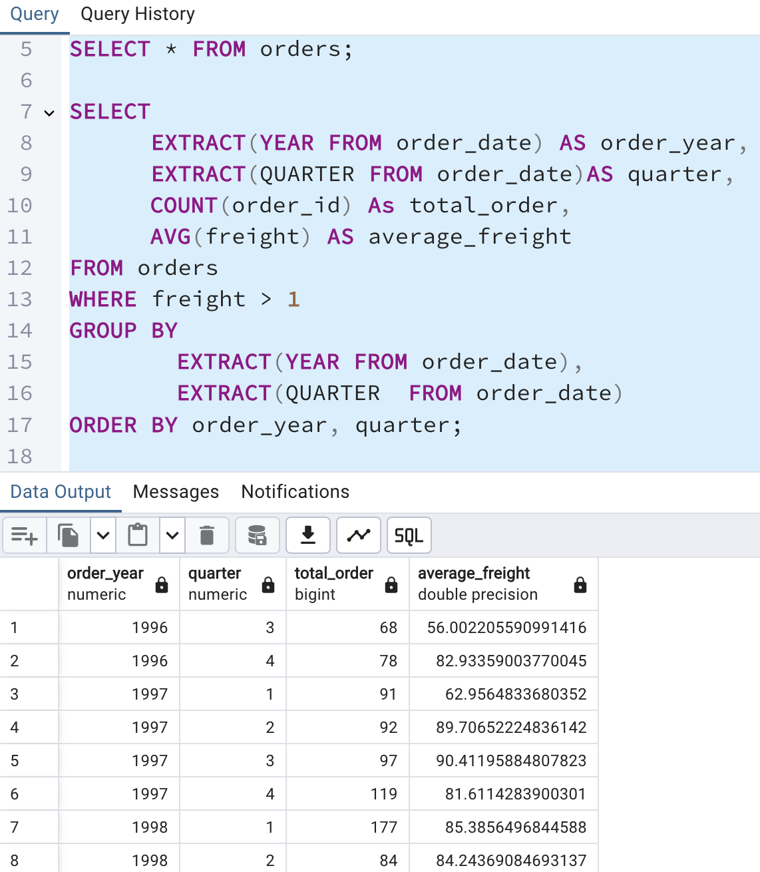

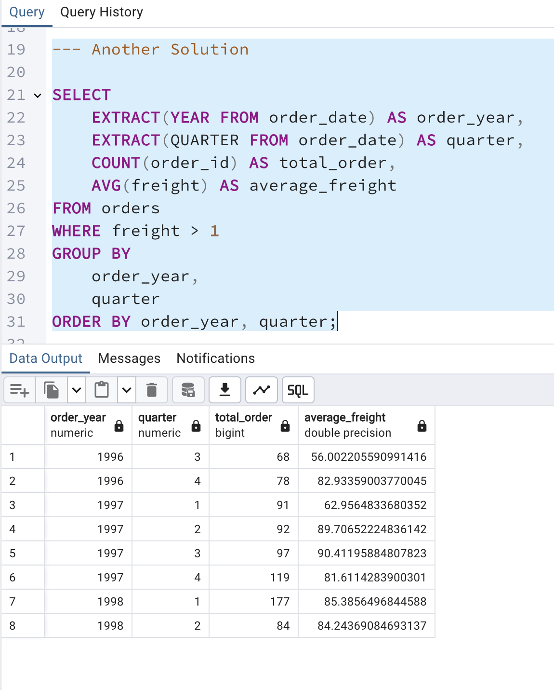

**2. GROUP BY with HAVING - High Volume Ship Regions**

**Display, ship region, no of orders in each region, min and max freight cost  
 Filter regions where no of orders >= 5**

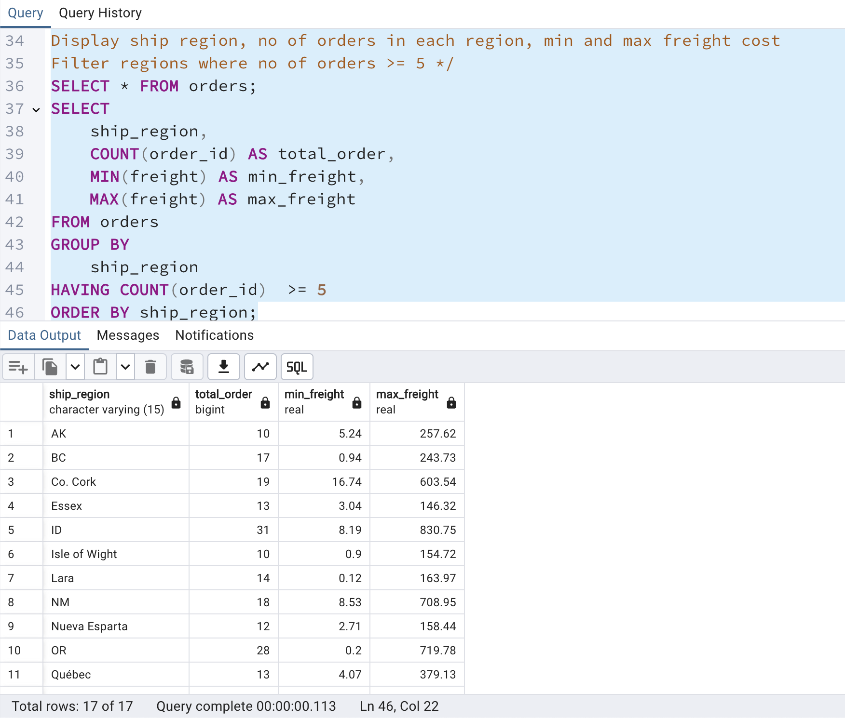

**3. Get all title designations across employees and customers ( Try UNION & UNION ALL)**

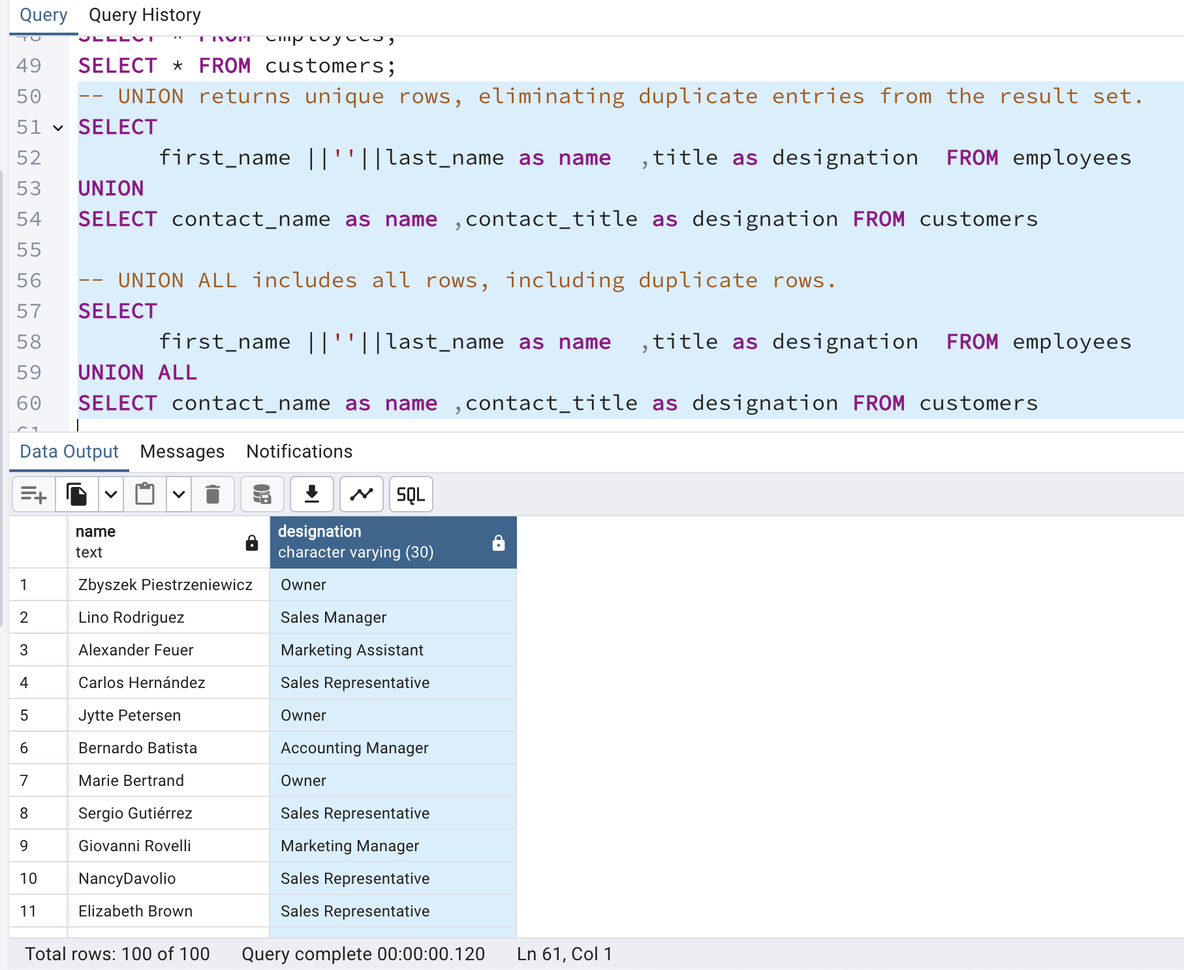

**4. Find categories that have both discontinued and in-stock products**

**(Display category_id, instock means units_in_stock > 0, Intersect)**

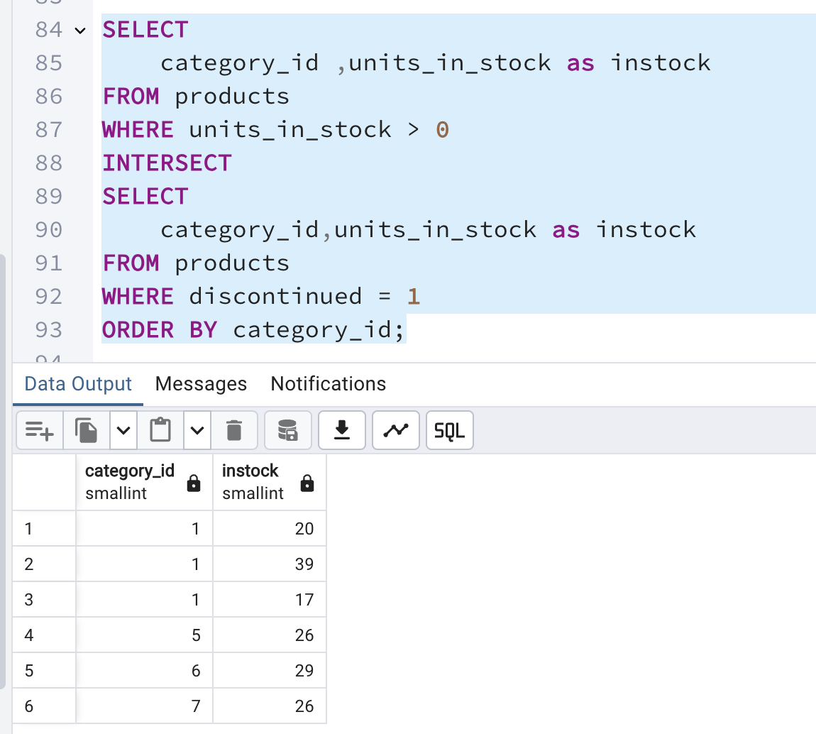

**5. Find orders that have no discounted items (Display the order_id, EXCEPT)**

